Use the information below to answer questions 1-3.
A warehouse store employs stockers and cashiers. Stockers earn $100 per day and cashiers earn $120 per day. The store schedules at most 55 employees per day. The store's daily payroll for stockers and cashiers cannot exceed $6000.
1. Which system of inequalities best describes the possible combinations of stocker and cashier scheduling?

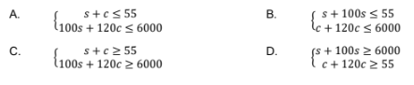
2. Which of the graphed systems best represents this situation?
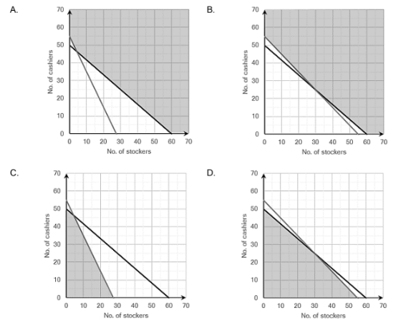

3. Which of the following statements about the situation is true?

- The store can schedule 30 stockers and 30 cashiers.
- The store can schedule 20 stockers and 20 cashiers.
- The store can schedule more than 55 employees per day.
- The store can schedule 20 stockers and 40 cashiers.
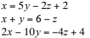
4. What is the solution to the system of linear equations?
- $(3, 2, 1)$
- $(2, 6, 4)$
- No solution
- Infinitely many solutions

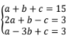

5. What is the solution to the system of linear equations?

- $a=-4, b=-9. c=20$
- $a=4, b=3. c=8$
- No Solution
- Infinitely Many Solutions

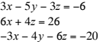

6. What is the solution to the system of equations?

- $(1,-6,-3)$
- $(1,-4,-5)$
- Infinitely many solutions
- No Solution

7. In triangle TUV, the measure of angle U is twice the measure of angle T. The measure of angle V is 80 more than that of T. Formulate the system of equations for this situation.

Equation 1:__________________________________________
Equation 2:__________________________________________
Equation 3:__________________________________________

Use the information below to answer questions 8 and 9.

Student A spent $9 on a bottle of school glue, a package of colored pencils, and a pencil pouch. Student B spent $16 on two bottles of school glue, three packages of colored pencils, and a pencil pouch. Student C spent $17 on a bottle of school glue, two packages of colored pencils, and two pencil pouches.
8. Which Augmented matrix best represents the system of linear equations that could be used to solve the system?
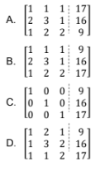

9. What price did the customers pay for a package of colored pencils?
- $1
- $3
- $5
- $9

10.A manufacturer of manila folders has three machines that, when all working, produce 592 boxes of folders per day. When only machine A and machine C are operational, they produce 352 boxes per day. Together, machine B and machine C produce 400 boxes per day.

Which system of linear equations could be used to determine the daily quantity of boxes of manila folders produced by each machine?

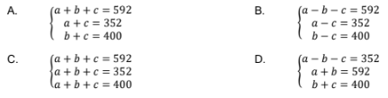

Use the information below to answer questions 11 and 12.
Asher spent $37 on four 4×6 picture frames, two 8×10 picture frames, and one 16×20 picture frame. Lucy purchased eight 4×6 frames and one 8×10 frame for $29, while Amelia spent $23 on one frame of each size.

11.Which system of linear equations could be used to determine the price of each type of party supply?

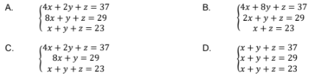

12. Which response best describes the price of each size of picture frame?

- 4$×$6 picture frames cost $5 each, 8$×$10 picture frames cost $8 each, and 16$×$20 picture frames cost $10 each.
- 4$×$6 picture frames cost $3 each, 8$×$10 picture frames cost $5 each, and 16$×$20 picture frames cost $15 each.
- 4$×$6 picture frames cost $1 each, 8$×$10 picture frames cost $11 each, and 16$×$20 picture frames cost $11 each.
- 4$×$6 picture frames cost $37 each, 8$×$10 picture frames cost $29 each, and 16$×$20 picture frames cost $23 each.

